Roopali Reddy Kallem

Rxk180054

MIS 6380.001

November 3, 2023

Assignment 10

Q1)

Twitter Network: Directed

Railway Network: Directed

Pedestrian Pathway Network: Undirected

Q2)

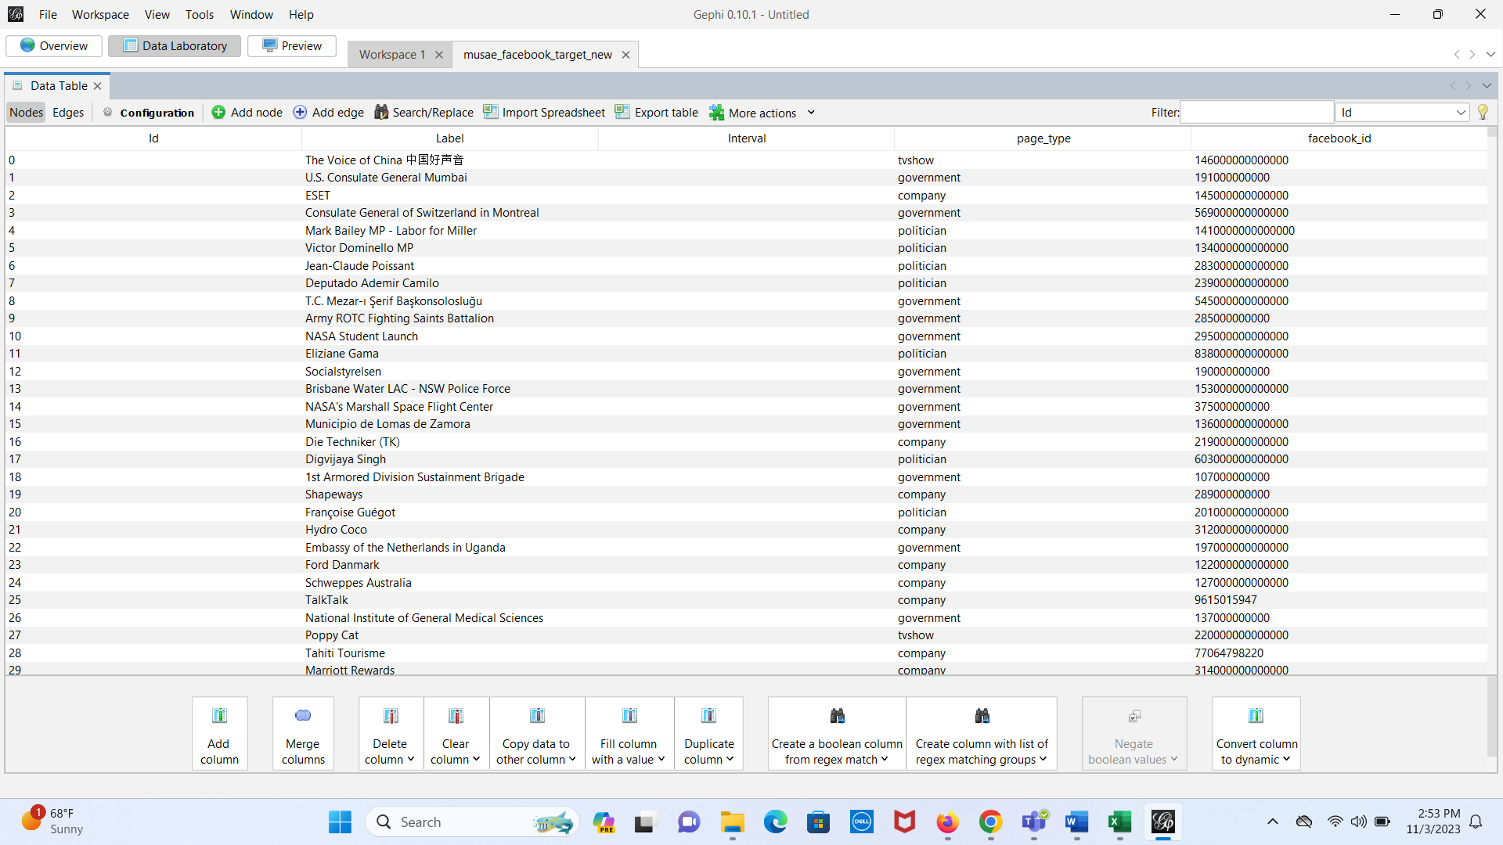

Q3)

Q4)

Q5) Average Degree: 15.220

Q6)

Q7)

4 types of pages:

Government

Company

Politician

TvShow

Q8)

Q9) Government

Q10) Number of Communities: 6

Q11)

Q12)

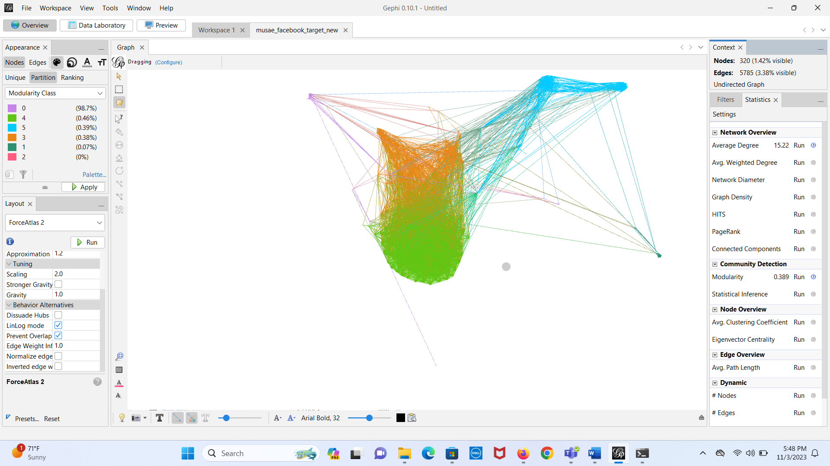

Q13) TvShows

Q14)

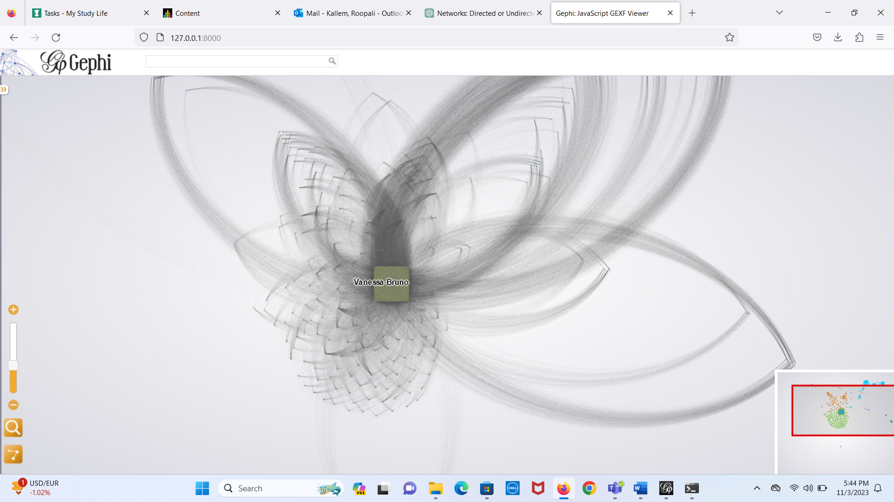

Zoomed view:

